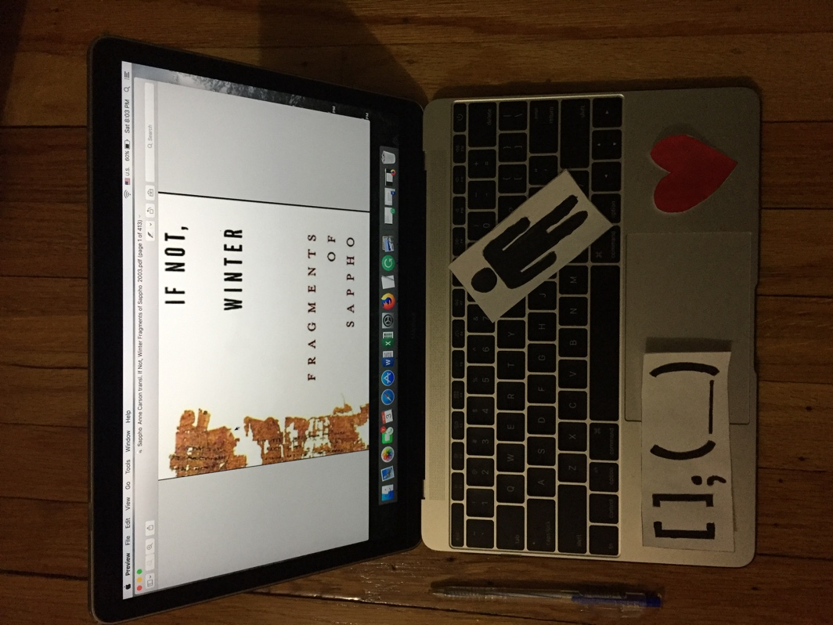

Tuan Nguyen

Book Bento for If Not, Winter: Fragments of Sappho by Anne Carson

A pen –

represented a main character in the story. This person loves to write poems and turns them into lyrics. Sappho is a poet lived in the city of Mytilene on the island of Lesbos. Throughout her life, she constantly wrote poems related to love, marriage, desire, and beauty. For example, in the poem 16, she mentioned, “Some men said army of horse, army on foot, and army of ship is a most beautiful thing on the black earth.” This indicates that Sappho beauty is not defined by representation or physical appearance, but beauty is “what you love”. Although many of Sappho poems are remain fragmented, they still give the reader a sense of feeling and desire of Sappho’s life.

Bracket, semicolon, and blank-

Sappho’s poems are incohesive with a lot many brackets and spaces in between making it difficult for the audience to understand the whole theme. However, this structure creates a mystery to Sappho’s poems which allows readers imagining freely. Thus, different people can have different analyses of Sappho’s poems.

Men-

Sappho mentioned the idea of how Sappho sees the beauty of men. In the story, she talked about Kerkylas who she married to and Phaon who she loved. She compared the beauty of men from the appearance rather than the beauty of the mind. Sappho only considered physical beauty as a priority to the beauty of the mind, which is classified as wisdom. Sappho believes the beauty of men only in their appearances.

A heart-

A heart represents her love for music and poetry. She was passionate to write poems cover topic of love, beauty, and men. Moreover, a heart can simplify Sappho’s love for a young woman in poem 31. The poem begins with Sappho saying, “He seems to me equal to gods that man whoever he is who opposite you sits and listens close to your sweet speaking.” She is jealous of the love of a young woman for a man, who is unknown. Sappho’s characteristic can be classified as bisexual.

A computer-

An eBook version of the book.